Sustainability Policy

Cleaning Scotland Ltd recognises that businesses can have a negative impact on the environment. We are committed to finding ways in which we can reduce the impact of our work both in the office and when work takes us away from the office.
The company is committed to:
- Preventing and reducing environmental impact
- Complying with relevant legal requirements and as such Cleaning Scotland has achieved environmental management standard ISO 14001 accreditation. Our legal and other requirements register significant aspects and objectives and targets are monitored on a monthly basis
- continuously improving on sustainability performance
- assuring that the policy will be well communicated and managed
It is our policy to:
- Recycle as much waste material as possible from paper to uniforms and technical equipment.
- Avoiding the use of paper wherever possible, for example, sending invoices and quotes via email as PDF files.
- Keeping energy usage low by making use of low energy light bulbs throughout, with lights automatically shutting off when the area is unoccupied and ensuring that computers are shut down after work.
- Reusing waste paper where possible, making use of the unused blank side for notes etc.
- Purchasing products made with recycled paper. For example, paper towels, printer paper
- Purchasing products with a lower environmental impact.
- Using low impact transport for travel to and from work and travel for business. We use public transport to attend meetings locally, car-pooling as much as possible and offering a Cycle Scheme to encourage staff to cycle to work.
- Avoiding unnecessary travel by making use of instant messaging, video and audio conferencing, telephone and email
- Using only fair trade tea and coffee in our premises

Signed: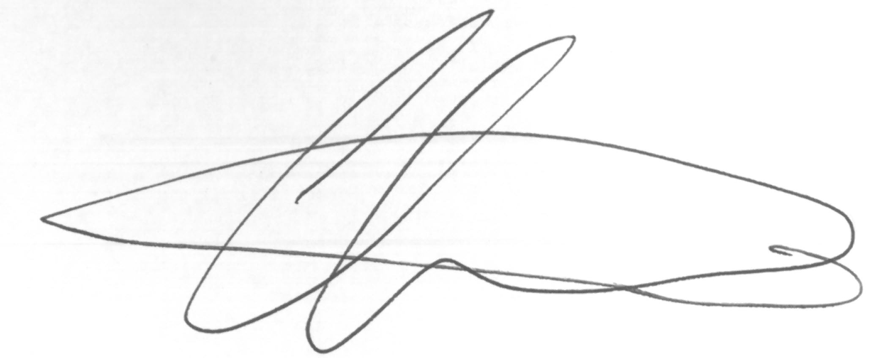
Managing Director Renewal Date:
4 January 2017: 3 January 2018

